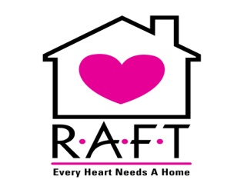
Eligibility Requirements
Residential Assistance To Families in Transition (RAFT)
To be eligible for the RAFT program you MUST meet ALL of the following requirements:
- Be homeless as defined by HUD.
  - A family that lacks a fixed, regular, adequate nighttime residence.
- Must be 18 years of age.
- Be a family as defined by HUD.
  - Pregnant woman
  - Single parent family
  - Two parent family
- Be a citizen of the United States, have documentation of permanent resident status, or have an Employment Authorization Card with an expiration date of at least six months form the anticipated move-in date.
- Must complete the RAFT application and interview process.
- Must be recommended by RAFT staff and approved by RAFT’s Policy Committee.
- Must submit to a national background check.

RAFT does not discriminate on the basis of race, color, religion, sex, sexual orientation, marital status, national origin, ancestry, familial status, source of income or disability.

